TEAM ID :PNT2022TMID45601

BATCH:B3 - 3M5E

PROJECT NAME : University Admit Eligibility Predictor

PREETHI K CLOUD ACCOUNT

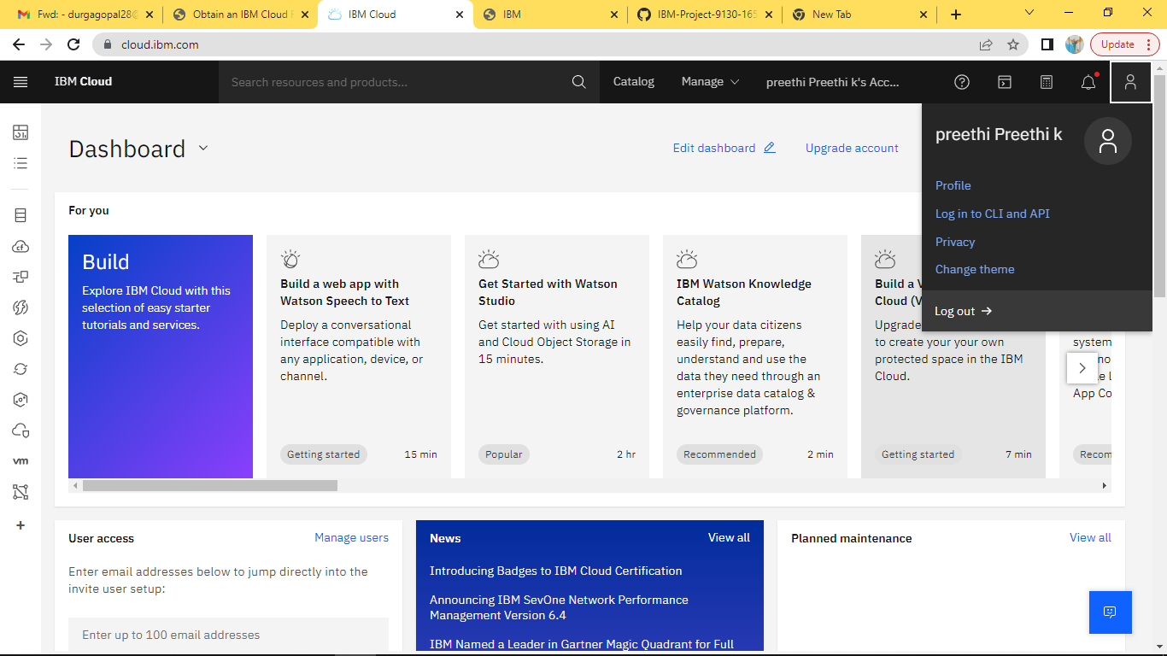

SHARMILA R CLOUD ACCOUNT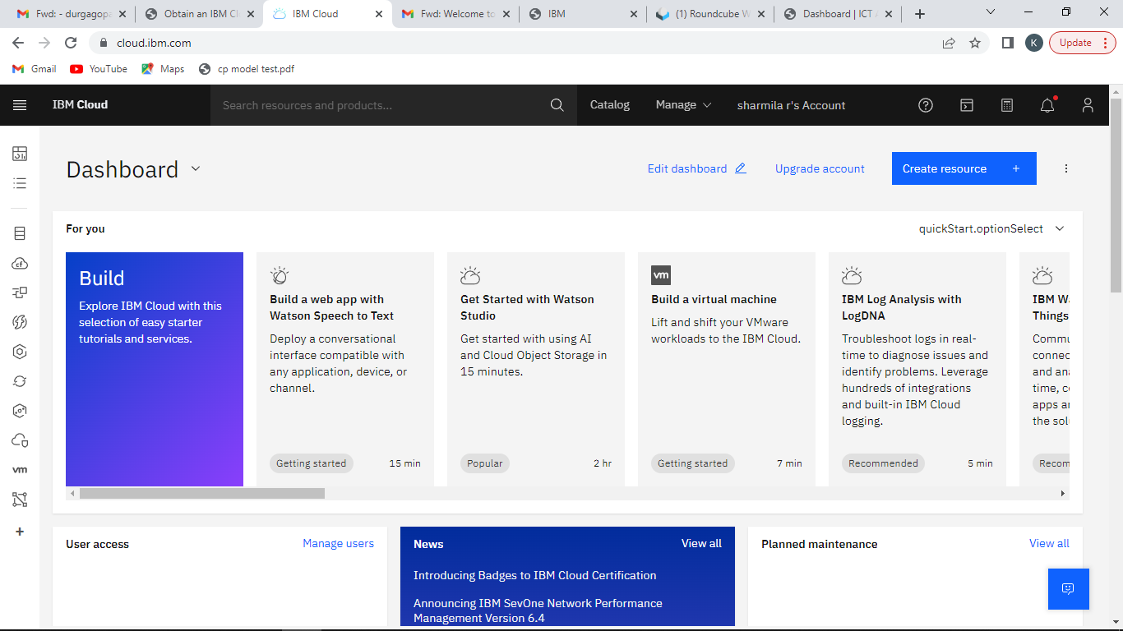

JENIFER J CLOUD ACCOUNT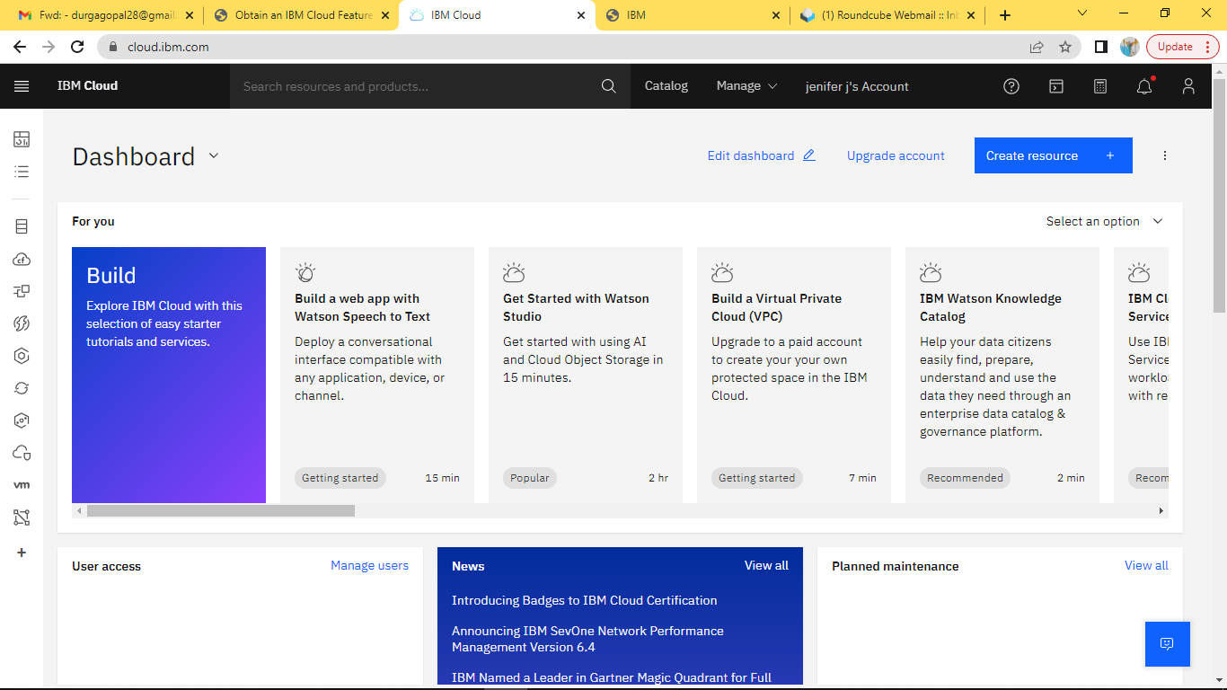 KARUNYA S CLOUD ACCOUNT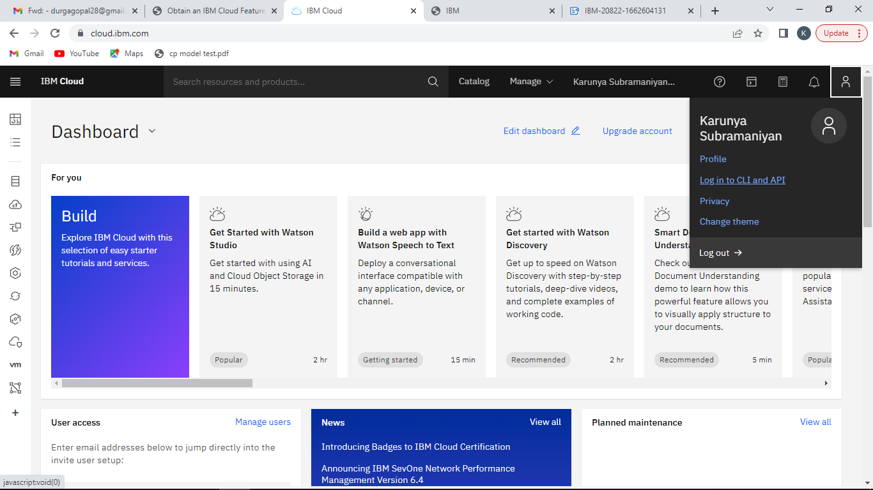

KAVIYA J CLOUD ACCOUNT

